Albert Lowry, Hidden Fortunes in Real Estate, Simon and Schuster 1983 First Ed 3rd print, Very good unclipped price $17.95 dust jacket with four taped and closed tears, fine hard cover with all 367 pages tightly bound with no marks of any kind. 8vo. (8.7 x 5.9 x 1.25 inches). ISBN 0671427210

ID 000172 Price $7.50 Box 26
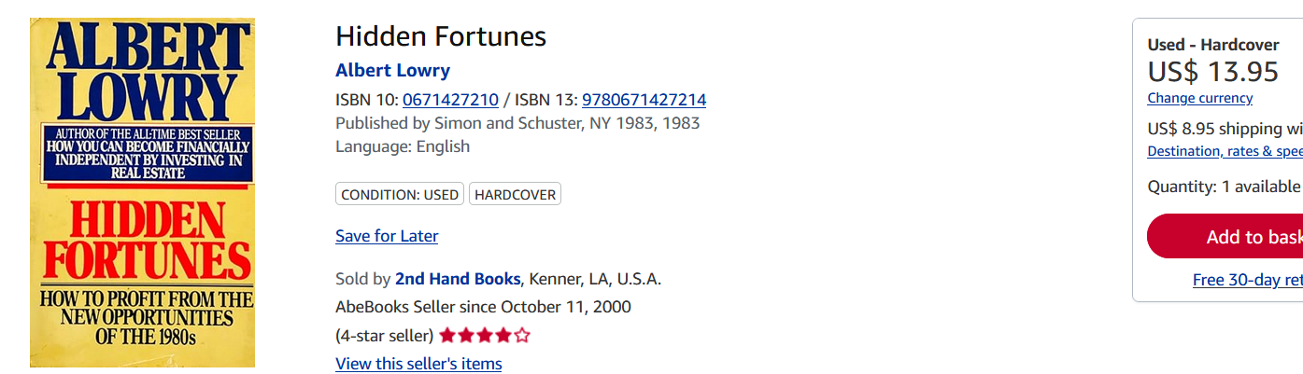
AbeBooks $3 to $45 signed

